MANAGING TOURISM SERVICES OF EAST BLACK SEA REGION OF TURKEY WITH MAPS
Arif Cagdas AYDINOGLU¹, Tahsin YOMRALIOGLU²
Karadeniz Technical Univ., Dept. of Geodesy and Photog. Eng. GISLab, Trabzon, Turkey
arifcagdas@ktu.edu.tr¹, tahsin@ktu.edu.tr²

Tourism contributes to economic and social development of a country and has emerging potential. Traditional methods to disseminate tourism-related information are inadequate. Therefore, building Tourism Management Information System (TMIS) with the supporting of Information and Communication Technologies (ICT) contributes tourism management services and users to reach the information easily and use it efficiently. TMIS should be produced to support Turkey’s development as a developing country. Due to East Black Sea region of Turkey has some socio-economic problems, tourism can be an important industry for supporting the region’s developments.

For building TMIS, a sustainable geodatabase model compliant with Culture Assets Automation System of Ministry of Culture and Tourism of Turkey was designed with considering tourism functions. This geodatabase includes natural, recreational, and historic tourism entities, transportation facilities, tourism facilities, and etc. The data convenient with the model was collected for East Black Sea Region of Turkey on Geographical Information Systems (GIS) environment. TMIS model with standardized geodatabase and cartographic elements enables to produce applications for tourism services and can be used for different tourism applications as a model. After TMIS was built for East Black Sea region of Turkey, decision maker and user oriented products were produced. User oriented products include tourism maps like wall paper, folded maps, tourism guide, and web based tourism applications with various cartographic capacity. With TMIS, decision makers can find optimal solutions to complex problems like where a tourism center should be built.

- INTRODUTION

Tourism can be defined as the act of travel for the purpose of recreation and business, and the provision of services for this act. Tourists are people who are “traveling to and staying in places outside their usual environment for not more than one consecutive year for leisure, business and other purposes not related to the exercise of an activity remunerated from within the place visited” (URL-1). Tourism is an information-intensive, information-sensitive industry, and a service industry, comprising a number of tangible and intangible components. The tangible elements include transport systems -air, rail, road, water and now, space; hospitality services- accommodation, foods and beverages, tours, souvenirs; and related services such as banking, insurance and safety and security. The intangible elements include: rest and relaxation, culture, escape, adventure, new and different experiences (URL-2).
Tourism Services are based on acquiring data and using the data effectively. ICT, therefore, enables to get, share, and distribute the data in tourism industry. Building TMIS with the helping of ICT provides disseminating information for tourism services and users. Presenting tourism data with geographic information or maps makes the data meaningful for both users and managers. GIS enables users to examine tourism data spatially and make required analysis and queries possible on these data. Managing and automating tourism data through GIS technology facilitates to planners, official employees and general public to use it in order to planning, development and marketing of tourism activity. Using GIS technology for TMIS has advantages. These advantages help in the simplification of processing of voluminous geographic-tourist information, referred to natural and cultural resources, tourist facilities, accessibility, transport, land uses among others (Colak and Aydinoglu, 2006).
In this study, to build TMIS, geodatabase is designed for East Black Sea Region of Turkey and the data was acquired and converted to digital format. TMIS convenient with the geodatabase model was built with the using of GIS techniques. And, decision maker and user oriented products were produced depending on user needs.

2. BUILDING TMIS FOR EAST BLACK SEA OF TURKEY

Tourism economy has an important place in Turkish Economy and has about 5% of General Domestic National Product. It brings 10 billion USA Dollars to the economy and provide nearly one and a half million employee of which is about the one to four of the recorded employment (URL 3). East Black Sea Region of Turkey having tourism potential was selected as a study area (Figure 1). The area covers 6 provinces including Artvin, Bayburt, Giresun, Rize, Gumushane, and Trabzon totally equal to 32269 sq km. This area is Turkey's greenest region with outstanding natural beauty and has its lush green mountains and valleys, glacial lakes, clear gushing mountain streams and long beaches. The area is also sprinkled with early Byzantine and Genoese monasteries and castles, rising impressively from the steep hill sides, and is renowned with their strong cultural traditions.
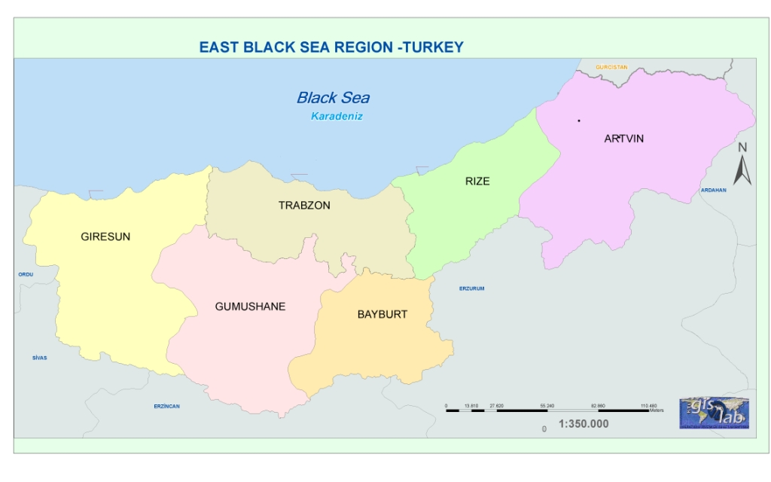
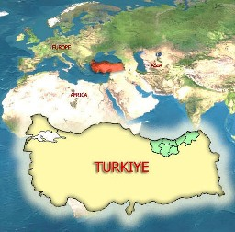

Figure 1. Study area

TMIS model was designed to produce documents aimed at managing tourism services. Taking tourism expectations into consideration, geodatabase was designed as seen on Figure 2. The data are divided into two parts, base and tourism datasets. Base datasets especially includes the layers reflecting real world objects such as topography, hydrograph, transportation, and administrative units. Tourism datasets includes historic, natural, and recreational, protected areas, and tourism facilities including hotels and some tourism attractive centers. A set of specifications were produced for creation, maintenance, and sharing GI. Specifications of TMIS include Datasets, Feature Types, Recommended Attributes, Domains, and Spatial Integrity Rules.
Base data such as road, river, lake, administrative unit, elevation were obtained and compiled from digital data prepared by KTU GISLab, the DOKAP Project Data, The General Command of Mapping of Turkey. These data were digitized from screen or edited graphically with the helping of GIS editing capabilities. Surface was created from elevation data and then covered by orto-imagery. Administrative areas and unit layers, related attributes were completed and edited from governmental sources. All these base data were collected on ArcGIS software as seen on Figure 4 and prepared depending on geodatabase design.
Information about Historic and Nature entities was collected from web sites of the Ministry of Culture and Tourism of Turkey, provinces’ governorships and from some catalogues. Information about recreation entities was collected from recreational and tourism web sites and sport maps. Historic, nature, and protected areas’ entities were marked with the helping of explanations on documents or determining location on similar maps. For each record on historic, nature, and recreation layers, related attributes were written to atribute tables. This geodatabase was revised with Culture Assets Automation System of Ministry of Culture and Tourism of Turkey.

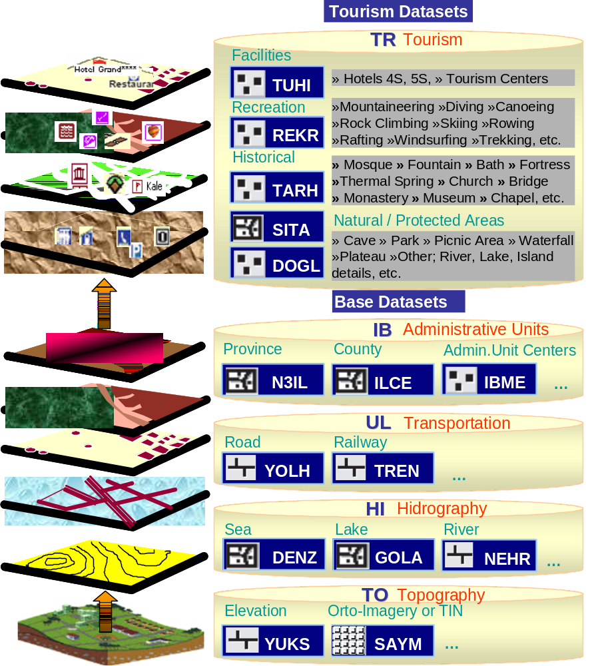

Figure 2. Datasets for TMIS

- PRODUCTS DIRECTED TO TOURISM SERVICES

Following geodatabase design, Geographic Model as base of TMIS was built. With cartographic design techniques, cartographic model which makes the maps and spatial data understandable and increase maps’ perception level was executed as seen on Figure 3.
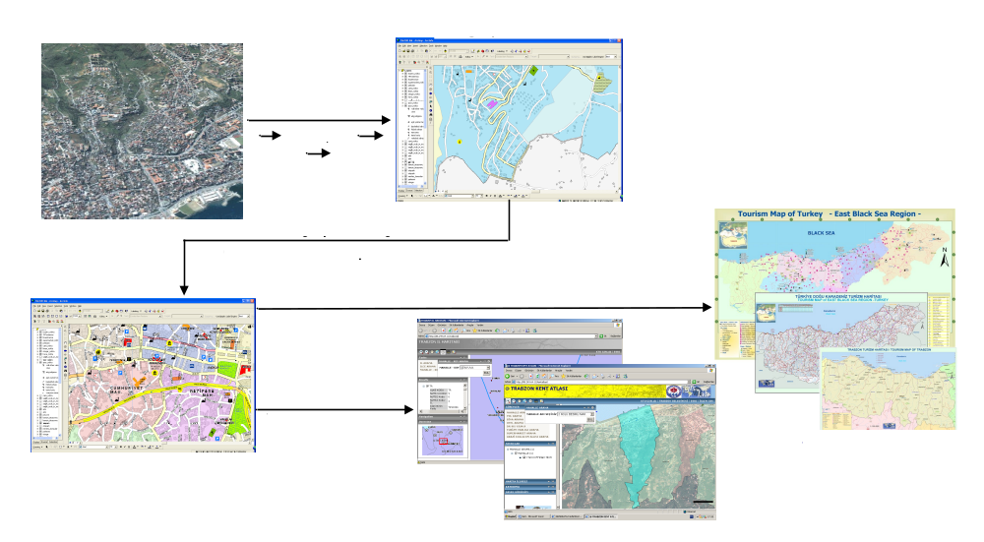
Figure 3. Basic Production Process for Tourism Maps

Tourism maps like wall paper, folded maps, and tourism guide were produced at regional and provincial level to support various tourism services. Each tourism object to be integrated in a tourist map product presents the location of object in geographic space. As seen on Figure 4, a regional tourism map on folded map and tourism guide format was produced for the region. Tourism maps can be created for each province, depending on cartographic model. A tourism web site was browsed from the internet with the using of ArcGIS Server architecture. A user can reach tourism maps and data, get route information about related tourism facilities and entities for East Black Sea region from anywhere all over the world. This system presents basic GIS functions. The users can get information about tourism entities easily.

- CONCLUSION

TMIS enables both decision makers and users to reach knowledge, maps and documentations for their needs. By updating database, maps and documents were produced easily with improved capabilities of access to knowledge, queries and spatial analysis of GIS. On this architecture, because the data can be maintained and updated in a centralized location, users can reach updated information. By this way, Various tourism products like trekking maps, route planning for a tourism site, and national park maps were produced and can be created continuously. The users can reach territorial tourism information with produced tourism products and internet tourism maps.
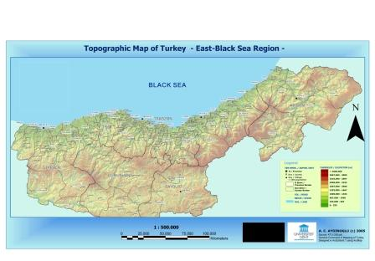
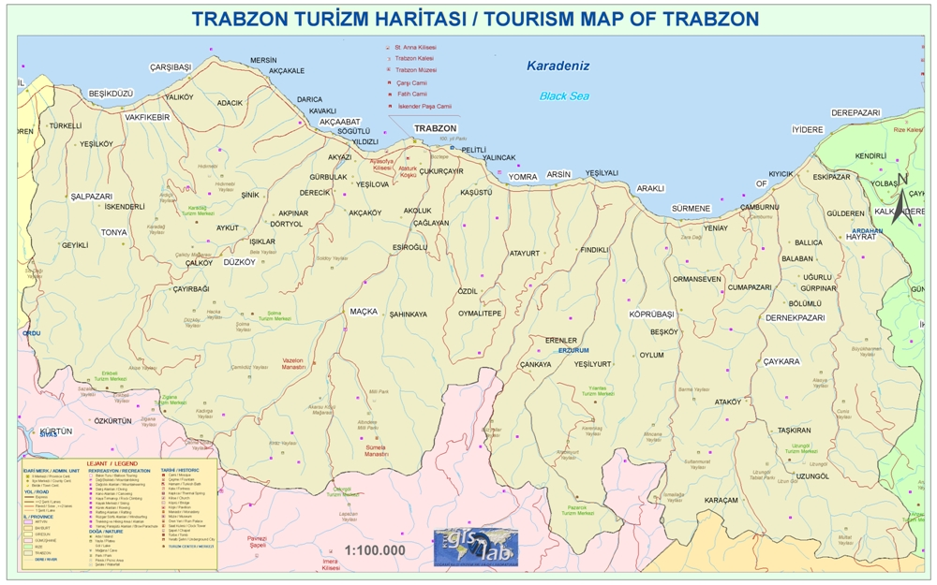
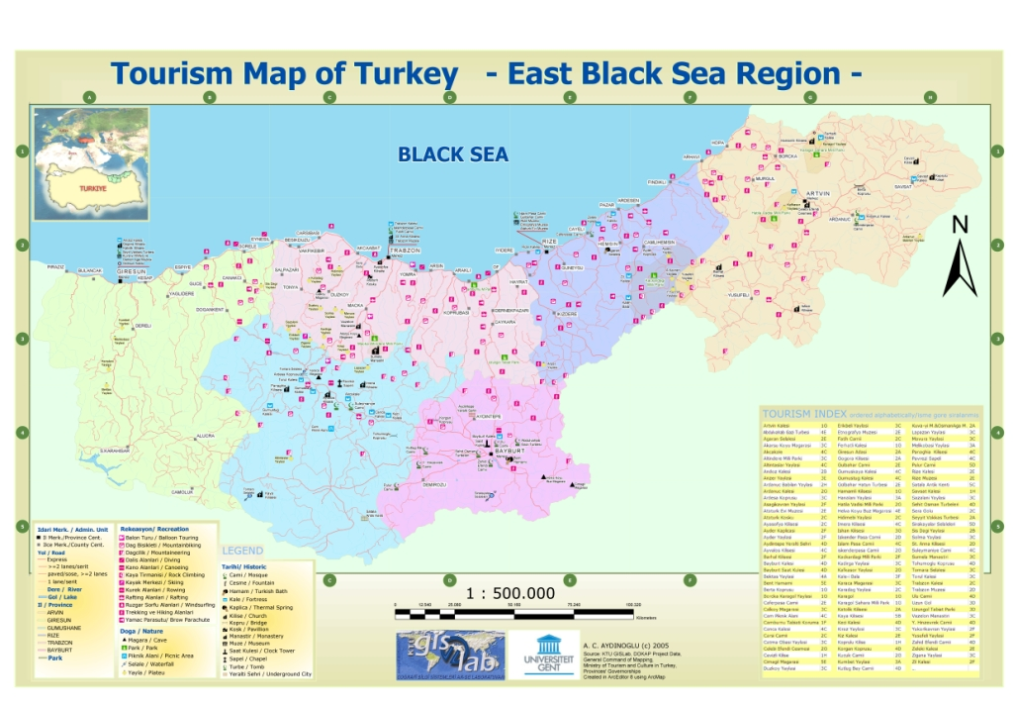

Figure 4. East Black Sea Region and Trabzon Province Tourism Maps

REFERENCES
Colak, H.E., Aydinoglu, A.C., Determining Regional Tourism Development Strategies of East Black Sea Region of Turkey by GIS, XXIII FIG Congress, Munich, Germany, October 8-13, 2006
URL-1. World Tourism Organization (UNWTO- OMT), http://www.unwto.org/, 2006.
URL-2. Wikipedia,The Free Encyclopedia, http://en.wikipedia.org/wiki/Tourism, 2006.
URL-3, Republic of Turkey, Ministry of Culture and Tourism Official Web Site, http://www.kultur.gov.tr, 2006.

